

COMPUTER LABORATORY INVENTORY MANAGEMENT SYSTEM

Information Technology Project 2025

Submitted by:

GERLIE M. TUMARU
RONA MAE P. MALAZZAB
MARK ANTHONY A. SOLA
JHON ABSALON V. RAMOS

Submitted to:

ALBERT A. CANLAS

Table of contents
1.Introduction
1.1Purpose………………………………………………………………………………………….1
1.2 Scope…………………………………………………………………………………………...2
1.3 Acronyms, and Abbreviations………………………………………………………………….3
1.4Reference……………………………………………………………………………………….4
1.5 Overview……………………………………………………………………………………….5
2.Functional Data Description……………………………………………………………………..ii
2.1Data Overview………………………………………………………………………………….6
2.2Data Structure…………………………………………………………………………………..7
2.3 Data Flow………………………………………………………………………………………8
2.4 Data Storage……………………………………………………………………………………9
3.Subsystem Description………………………………………………………………………….iii
3.1 Subsystem Overview………………………………………………………………………….10
3.2Subsystem 1: [Subsystem Name] ……………………………………………………………..11
3.3Subsystem 2. [Subsystem Name] ……………………………………………………………..12
3.4 Subsystem 3. [Subsystem Name] …………………………………………………………….13
4.System modeling and Simulation Results……………………………………………………….iv
4.1System Model…………………………………………………………………………………14
4.2Simulation Results…………………………………………………………………………….15
5.Products…………………………………………………………………………………………..v
5.1Product Overview……………………………………………………………………………..16
5.2Product1: [Product Name] ……………………………………………………………………17
5.3Product2: [Product Name] ……………………………………………………………………18
5.4Product3: [Product Name] ……………………………………………………………………19
6. Appendices……………………………………………………………………………………...vi
6.1Appendix A: Glossary…………………………………………………………………………20
6.2Appendix B: Reference………………………………………………………………………..21
6.3AppendixC: Change Log……………………………………………………………………...22

1.Introduction
  - Purpose
The system defines the goal of computer laboratory maintenance purpose and is used to improve efficiency so that easier to find, update and report inventory data are all about their level. Lab Inventory of Computers it entails keeping a record of all computers.
  - Scope

- Tracking and managing assets: Monitoring computer lab equipment, software, and other resources.
- Inventory Control: Keeping tabs on inventory levels, including hardware, software, and supplies
- Software Management: Overseeing software licenses, expiration dates, and compliance.
- Maintenance and Repair: Schedule and tracking equipment maintenance, repairs, and upgrades.
- User Access Management: Controlling user access to lab equipment and resources.
- Reporting and Insights: Generating reports on inventory, equipment usage, maintenance, and other key metrics.
- Alerts and Notifications: Sending notifications for maintenance, software updates, and other important events.

  - Definitions, Acronyms, and Abbreviations
- A system for monitoring and controlling computer lab supplies, software, and other assets is called a computer lab inventory management system, or CLIMS.
- A system for tracking and managing computer lab inventory, including supplies, software, and hardware, is called CoLabIMS, or Computer Laboratory Inventory Management System.
- Laboratory Inventory Management System, or LablMS, is a system for keeping track of and managing supplies, equipment, and other assets in laboratory.
- The Computer Laboratory Asset System, or CLAS, is a system for monitoring and controlling the hardware, software, and other equipment used in computer labs.
- A system for tracking and managing laboratory inventory, which includes supplies, equipment, and other assets, is called a Laboratory Inventory Management System, or LIMS. System that aid in management and tracking of computer lab assets, equipment, and inventory are referred to by these acronyms and abbreviations.

  - Reference
https://www.scribd.Com/doc/48045624/ SRS-for-Internet-Lab-Management-System
https://sist.sathyabama.ac.in/sist_naac/documents/1.3.4/b.e-cse-batchno-184.pdf
https://ojs.Aaresearchindex.com/index .php/aasgbcpjmra/article/view/13359
https://www.Scribd.com/document/238945519/Computerized-inventory-system

  - Overview
- Asset Tracking: Managing desktops, laptops, servers, and peripherals.
- Inventory Control: Keeping an eye on hardware, software, and consumables upgrades benefits.
- Optimized Asset Use: Cutting waste and increasing efficiency.
- Minimized Downtime: Proactive maintenance and repair.
- Streamlined Inventory: Reducing administrative tasks.
- Data Driven Decisions: Using analytics to inform decisions.
- Enhanced Security: Ensuring software compliance and lowering risks.
- System Goals: The system is designed to provide a centralized and automated method of managing computer lab assets, ensuring efficient utilization, proper maintenance, and effective security.
2. Functional Data Description
- Asset Management: Equipment details, including ID, type specifications, serial number, and location.
- Inventory Tracking: Monitoring inventory levels, including quantity, threshold alerts, and updates.
- Software License management: License details, including software name, key expiration date, and license count.
- Maintenance Records: Scheduling history, and records of repairs and history, and records of repairs and upgrades.
- User Management: User roles, access levels, and activity logs.
- Reporting Generating reports on inventory, usage, maintenance, and software compliance.

2.1 Data Overview
Overview of Data for the Computer Lab Inventory Management System (SRS) An overview of the data entities that are under the control of the computer lab inventory management system is given in the section. The following describes the core set of data entities and their relationships that underpin the system’s.
- Hardware Assets: This is the main data entity used to keep track of all the lab’s actual equipment. The goal is to keep an accurate and comprehensive record of every piece of hardware, along with its location, specifications, and state of repair.
Important information: A distinct number for every asset. Type of computer device (e.g., printer, monitor, PC). Details about the manufacturer and model. Comprehensive technical details. The actual location within a particular workstation and lab. The state of operations (e.g., Under Repair Operational). Information about purchases and warranties.
- Software: This data entity keeps track of all installed software, including license details, on the computers.
GOAL: To manage software versions, track software assets, and guarantee license compliance.
- Location: This entity establishes the lab’s physical configuration, logically allocating hardware assets.
Goal: To make asset location easier by offering a hierarchical structure that makes management and reporting simple.
- Users and Access: This data keeps track of the details of the people who use the lab and the t
Goal: To monitor lab usage, manage user access to the system, and supply support contact details.
Important information: A distinct user ID. Role of the user (e.g., Student, Lab assistant, Administrator). Contact details (email, name). Credentials for user authentication (password hash, for example). The system’s access right and permission.
- Maintenance and support all activities pertaining to the maintenance and repair of software and hardware tracked by this data entity.
Goal: To help manage asset lifecycles and spot reoccurring issues by offering a historical record of all maintenance event.

2.2 Data Structure
Equipment table
Equipment_ID Integer (PK) Unique ID for each equipment
thth
Equipment_Name Varchar (100) Name of the equipment
thth
Category Varchar (50) Type/category (e.eg., Desktop, Printer)
thth
Brand Varchar (50) Brand of equipment
thth
Model Varchar (50) Model number/name
thth
Serial_Number Varchar (50) Manufacturer’s serial number
thth
Purchase_Date of purchase
thth
Status Varchar (20) Available, in-use, under maintenance Retired
thth
Location_ ID Integer (FK) References the lab or room where it is stored
thth

Location Table
Field Name Data Type Description
thth
Location _ID Integer (PK) Unique ID for each lab /location
thth
Location_ Name Varchar (100) Lab name or number
thth
Building Varchar (50) Building name or code
thth
Room Number Varchar (10) Room number
thth

User Table
Field name Data type Description
thth
User_ ID Integer (PK) Unique ID for each system user
thth
Name Varchar (100) Full name of user
thth
Role Varchar (50) Admin, Staff, technician
thth
Email Varchar (100) Content email
thth
Password Varchar (255) Hashed password
thth
Transaction Table
Field Name Data Type Description
thth
Transaction_ ID Integer (PK) Unique transaction ID
thth
Equipment_ ID Integer (FK) References Equipment table
thth
User_ ID integer (FK) References user table
thth
Action_ Type Varchar (50) Borrowed, Returned, Transferred, Maintenance
thth
Transferred Maintenance
thth
Date_Action DateTime Date And Time of the transaction
thth
Remarks Text Additional Notes
thth

Maintenance Table
Field Name Data Type Description
thth
Maintenace_ID Integer (PK) Unique Maintenance record ID
thth
Equipment_ID Integer (FK) References Equipment table
thth
Date_Reported When issue was reported
thth
Date_Resolved When issue was fixed
thth
Technician_Name Varchar (100) Name of Technician
thth
Issue_Description Text Description of problem
thth
Action_Taken Text Repair or replacement actions
thth

2.3 Data Flow:
User Registration and login:
Input | Username, password, email, name
Process | System creates a new user account
Output | New user account is created and stored in the database.

System Processing
Input | Details about computer laboratory equipment, software, and other assets.
Process | System store and manage inventory data.
Output | System generates reports and insights on inventory levels, usage, and trends.

Database Updates
Input | Users submit request to update inventory data, such as adding new items, editing existing items, or deleting items.
Process | System validates the update request and data for accuracy and completeness
Output | System displays a confirmation message indicating the update was successful.

System Outputs:
input | Information about computer laboratories about computer equipment, software, and other assets.
output | The system stores and manages inventory data.
process | The system generates reports on inventory levels, usage and trends.

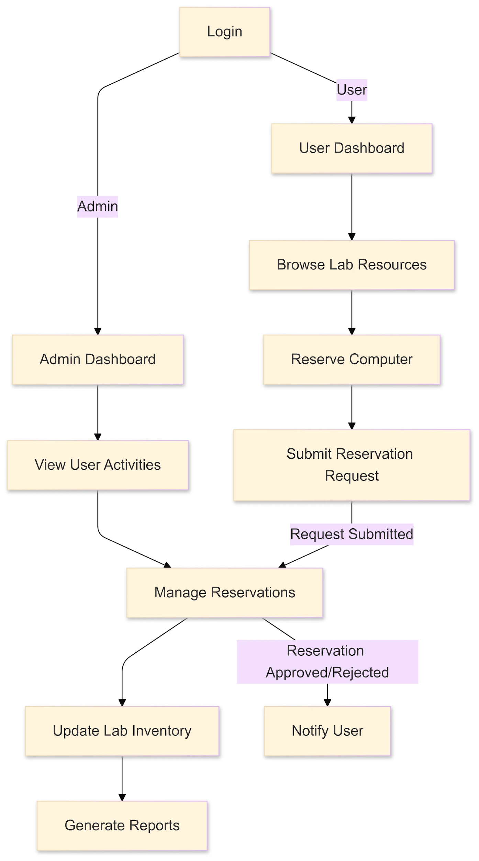

DATA FLOW DIAGRAM LEVEL 1

2.4 Data Storage
The Computer Lab Inventory Management System will store all operational data in a Relational Database Management System (RDBMS) such as MySQL or PostgreSQL. This ensures data is stored in a structured, secure, and easily retrievable format.

Database Storage
- Tables will represent the main entities:
- Users- stores user account and profile details.
- Items- stores inventory details of lab equipment.
- Transactions- logs borrowing, returning, and related activities.
- Maintenance- stores repair and service records.
- Primary keys ensure each record is uniquely identifiable.
- Foreign keys maintain relationships between tables for data consistency.
- Indexes will speed up queries for frequently accessed fields.

- File Storage (Optional)
- Files such as receipts, invoices, or maintenance reports will be stored in a secure file system.
- The file path or reference will be stored in the database for retrieval.

3. Subsystem Description
3.1 Subsystem Overview:
The Computer Laboratory Inventory Management System comprises multiple interconnected subsystems, including Inventory Management, Asset Tracking, Order Management, Maintenance and Support, and Reporting and Analytics. This subsystem collaborates to deliver efficient asset management, enabling accurate tracking, informed decision-making, and streamlined operations. By combining these components, the system provides a holistic solution for managing computer laboratory inventory and assets.
1. Inventory Management Subsystem
- Tracks and manages computer laboratory equipment and software.
- Includes features for adding, editing, and deleting inventory items.

2. Asset Tracking Subsystem
- Monitors the location and status of computer laboratory assets.
- Includes features for checking out and checking in assets.
3. Order Management Subsystem
- Manages orders for new equipment, software, or services.

- Includes features for generating purchase orders and tracking order status.
4. Reporting and Analytics Subsystem
- Generates reports on inventory levels, usage, and trends.
- Provides insights for data-driven decision-making.
5. User Management Subsystem
- Manages user accounts and access levels.
- Includes features for user authentication and authorization.
6. Notification and Alert Subsystem
- Sends notifications and alerts for inventory-related events.
- Includes features for customizing notification preferences.
7. Maintenance and Support Subsystem
- Schedules and tracks maintenance and repairs for computer laboratory equipment.
- Includes features for logging issues and tracking resolution.

3.2 Subsystem 1: [Inventory Management Subsystem]
This subsystem is responsible for managing the inventory of computer laboratory equipment, software, and other assets. Its key functions include:
1. Inventory Tracking: Tracking the quantity and location of inventory items.
2. Inventory Updates: Updating inventory records in real-time.
3. Inventory Reporting: Generating reports on inventory levels and usage.

This subsystem tracks and manages computer laboratory assets, including:
1. Asset Location: Tracks the physical location of assets.
2. Asset Status: Monitors the status of assets (e.g., available, in-use, maintenance).
3. Asset Assignment: Assigns assets to specific users or locations.
- Improved Asset Utilization: Optimizes asset usage and reduces downtime.
- Reduced Loss: Minimizes asset loss and theft.
- Increased Efficiency: Streamlines asset management processes.
- Order Creation: Creates and tracks orders for new equipment, software, or services.
- Order Approval: Manages order approval workflows
- Order Fulfillment: Tracks order fulfillment and delivery.

3.4 Subsystem 3. [Order Management]

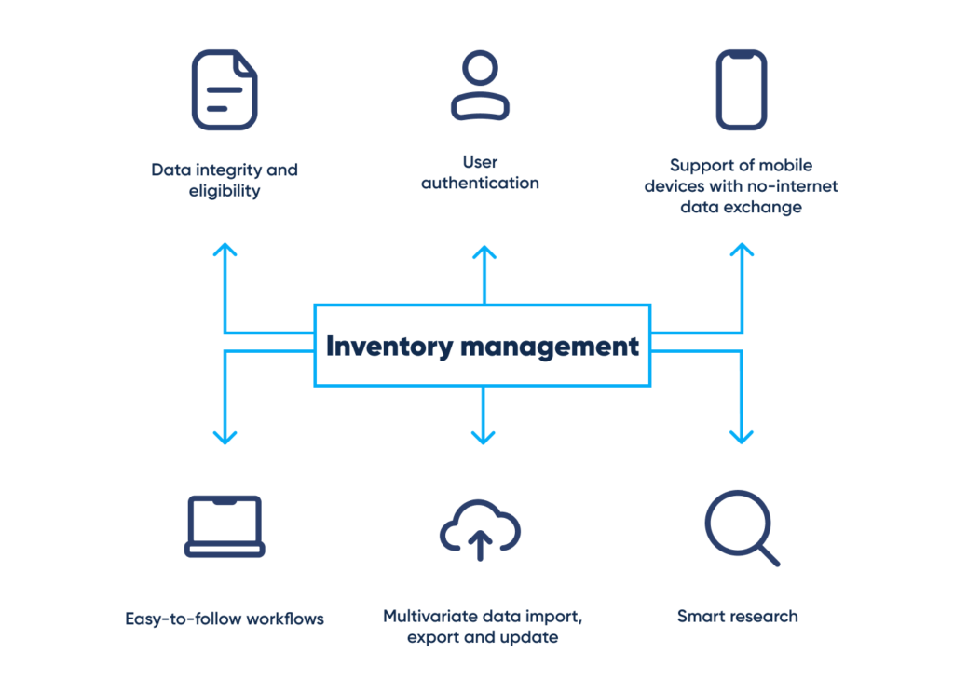

4. System Modeling and simulation Results
4.1 System Model:

Manage and maintain computer systems, networks and infrastructure.

Designs, implements, and manages databases.

Oversees network infrastructure, security, and performance.

Focuses on implementing and enforcing security measures.
ADMIN

4.2 Simulation Results
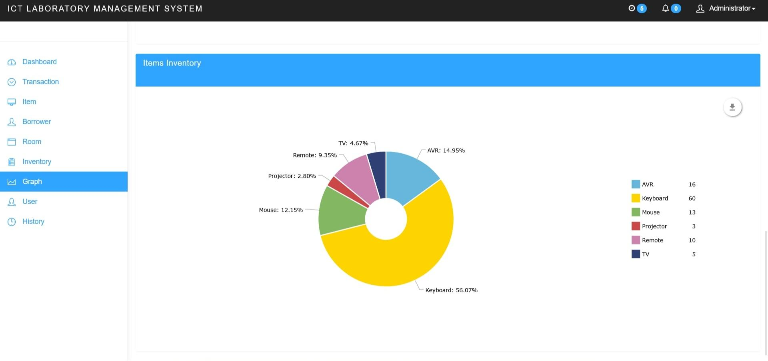
5. Products
5.1 Product Overview
A Computer Lab Inventory Management System is a software solution that helps manage and monitor computer labs efficiently. Its key features include user registration, lab reservations, inventory management, report generation, damage tracking, and borrow management. The system offers functionalities like item management, category management, user management, and system monitoring with real-time alerts. By automating routine tasks, it enhances security, optimizes resource utilization, and provides valuable insights for data-driven decisions.

5.2 Product 1:
Inventory Management Features
- Asset Tracking: Track computer hardware assets, including desktops, laptops, and peripherals.
- Inventory Updates: Update inventory records in real-time to reflect changes in inventory levels or locations.
- Inventory Reporting: Generate reports on inventory levels, usage, and trends.
- Low-Inventory Alerts: Send alerts when inventory levels reach a certain threshold.
- General Lab Inventory Management Software: Offers an all- purpose solution for laboratories that handle multiple material categories.
- ELN-Integrated Inventory Management systems: Combines Electronic Lab Notebooks (ELNs) with inventory tracking to streamline data entry and enhance workflow efficiency.
- Sample Biobank Inventory Management Software: Provide precise tracking with accurate labeling, storage, and retrieval process to maintain sample integrity and accessibility.
Inventory Management

Customer Management

Login Management
Order Management

Computer inventory Management system

6. Appendices
6.1 Appendix A: Glossary
Asset: A valuable item or resource, such as computer hardware or software, used in the laboratory.
Asset Management: The process of tracking, maintaining, and optimizing laboratory assets.
CLMS: Computer Laboratory Management System, a software application designed to manage laboratory assets, inventory, and maintenance.
Hardware: Physical components of a computer system, such as desktops, laptops, servers, and peripherals.
Inventory: A list of assets, supplies, and materials used in the laboratory.
Inventory Management: The process of tracking, storing, and maintaining laboratory inventory.
Laboratory Information System: A software application designed to manage laboratory operations, including asset management, inventory control, and maintenance scheduling.
Maintenance: Regular activities performed to prevent equipment failure, ensure optimal performance, and extend asset lifespan.
Software: Programs and operating systems used in the laboratory, including licenses and versions.
Software License Management: The process of tracking, managing, and ensuring compliance with software licenses.

6.2 Appendix B: Reference
Design and Implementation of a Computer- Based Inventory Management System
Inventory Management Systems: A Review by International Journal of Production Research.
IEEE Explore: Search for articles on “inventory management systems” or “computer lab inventory management”.
ACM Digital Library: Search for articles on “inventory management systems” or “lab management systems”.
ResearchGate: Search for publications on “inventory management systems” or “computer lab management”.

